Optimization of Electric Vehicle Charging Stations Using a Random Forest Regressor

Dhanush R Gowda
Department of CSE(AI&ML)
Dayananda Sagar University, Bengaluru, Karnataka, India
dhrgowda5@gmail.com
Bharath H
Department of CSE(AI&ML)
Dayananda Sagar University, Bengaluru, Karnataka, India
hbharath844@gmail.com
Chinmay C
Department of CSE(AI&ML)
Dayananda Sagar University, Bengaluru, Karnataka, India
cchinmay474@gmail.com
Sugandha Saxena
Department of CSE(AI&ML)
Dayananda Sagar University, Bengaluru, Karnataka, India
Sugandha.s-aiml@dsu.edu.in
Ajith R B
Department of CSE(AI&ML)
Dayananda Sagar University, Bengaluru, Karnataka, India
ajithrb25@gmail.com

Abstract—This Work aims to address the public policy challenge of optimizing Electric Vehicle (EV) charging station infrastructure to meet the demand for transportation electrification in India. The current inability of electric vehicles (EV) to be integrated into the electricity distribution network is due to inefficient placement and the demands imposed by the current infrastructure. Many of these studies have focused on a range of options to prevent inefficient placement and the stresses placed by EV chargers on the electricity distribution network. However, with the introduction of national guidelines requiring EV chargers to be installed according to national standards and to provide fair access to charging options, this work aims to further investigate, analyze and optimize the placement and sizing of EV charging stations by using advanced analytics in combination with clustering algorithms to improve user access to charging, improve the efficiency of the grid and provide an economical solution. Research Methodology The research employs geospatial mapping, estimating demand through forecasting, and testing scenarios based on policy and behaviour restrictions, using the following datasets: up-to-date locations of stations, automotive traffic counts on roads leading to these stations, an overview of the electrical grid within the area(s) of interest, and population density. These deliverables will provide useful information for planners, investors, and governmental agencies planning Electric Vehicle (EV) Charging Station networks that will facilitate the transition to low-carbon (EV) mobility, especially for urban and interurban communities in India.
Keywords—K-Means Clustering, Load Flow Analysis, Smart Grid, Sustainable Mobility, Geospatial Mapping, Demand Forecasting, Power Distribution Network.

Introduction
The global drive towards Sustainable Mobility has driven substantial increases in the adoption and use of Electric Vehicles (EVs) [1], [2], [10], [20]. This transition has environmental benefits, but at the same time, it has an enormous impact on existing Electricity Grids and Charging Infrastructure [4], [15], [16], [19]. Charging Stations for EVs – particularly in congested City Centers such as Bangalore – represent the new critical nodes of a new Energy Ecosystem [2], [12]. There is a need to manage the large, variable electric power demands of these Charging Stations while continuing to provide the proper level of service quality for EV Owners as well as maintaining the local Electric Grid [4], [15].
Fixed Power Allocation: a.k.a. static allocation (charging rates set regardless of conditions) is inefficient and can create strain on the power grid during high-demand periods, lead to lower charging speeds for multiple vehicles sharing a charger, and waste resources during low-demand times [11], [14], [16]. A new method of power allocation based on real-time data (e.g., grid load, vehicle traffic, time of day, etc.) is required. A smart system to assess operating conditions in real time could allocate the minimum power necessary for optimal charger performance, thereby maximizing efficiency and sustainability [1], [11], [13].
The development of Electric Vehicle (EV) charging infrastructure is grounded in several core theoretical concepts. Smart charging theory explains how EV load can be scheduled and coordinated to reduce peak demand and improve grid efficiency, as shown by Salam (2024) [1] and Li et al. (2022) [11]. This forms the basis of demand response within smart grids [6], [20].

Literature Review
The purpose of Electric Vehicle Charging Station Optimization is to utilize scientific models, innovative algorithms, and practical application of real-world data to improve both the site and performance of all EV charging station networks. The Optimization of EV Charging Station networks employs multiple techniques (e.g., Mathematical Programming, Geospatial Analysis, and Machine Learning) to accomplish three objectives: (1) Minimize Losses to the Power Supply; (2) reduce EV Charging Costs; and (3) provide a Reliable Electric Grid while maximizing User Convenience, Reducing Waiting Time, and Improving Accessibility [1], [3], [4], [12], [18]. For example, optimization has the potential to solve problems, including (i) accommodating rapid fluctuations in electricity pricing, (ii) providing trade-offs between Technical and Economic Objectives. The ultimate goal of the Optimization of Public Charging Stations is to increase the Long-Term Impact of Sustainable Mobility Solutions, Reduce Carbon-Based Transportation Emissions, and Provide Support for Hybrid Electric Vehicle Use. By efficiently locating, sizing, and scheduling public EV Charging Stations, the City and Public Utilities can provide further opportunities for Sustainable Mobility Solutions while considering the Efficiency of Electric Grid Integration and Reduced Carbon Emission Levels [2], [3], [5], [12].

TABLE I: Summary of Recent Research on EV Charging Station Optimization

Year | Methodology | Result | Limitation
2024 [1] | Mixed-Integer Linear Programming (MILP) for coordinated EV charging with dynamic tariffs (Salam). | Achieved ~15% reduction in peak load; demand curve flattening observed; TOU pricing improved grid stability and reduced charging cost. | Assumes full user participation and centralized decision-making; real-world user compliance may vary.
2024 [2] | Systematic evaluation of mathematical, heuristic/metaheuristic, and simulation-based models for EVCS allocation and sizing (Yuvaraj et al.). | Provides a multi-objective framework balancing cost, service reliability, and grid constraints; highlights the role of GIS for efficient deployment. | Overlooks stochastic uncertainties in demand, charger availability, and renewable variability; suggests future work on probabilistic modelling.
2022 [3] | Mixed-Integer Nonlinear Programming (MINLP) for EVCS location optimization with spatial demand and network constraints (Zhou). | Minimizes system cost (travel + grid losses); validated optimal site selection using real urban travel data. | Does not fully capture seasonal or high-variability traffic patterns; accuracy depends on the granularity of transport network data.
2022 [4] | Load-flow analysis + multi-objective optimization for EVCS siting/sizing considering power losses & voltage stability (Tesfahunegn et al.). | Reduced distribution losses by ~10%; maintained voltage stability; achieved balanced economic–technical trade-off. | Relies heavily on accurate grid simulation; it may be complex to scale for national-level distribution networks.
2024 [5] | Custom K-Means clustering algorithm for EVCS location optimization (Abdullahi). | Improved spatial placement of charging stations; minimized user travel distance; suitable for large datasets. | Clustering ignores power grid constraints; results depend on initial cluster selection and dataset quality.

Methodology

Using conventional data science libraries such as pandas, NumPy, and scikit-learn, implemented via Python. There are many phases to the project's workflow, including synthetic data creation, working on the data, training models, and evaluating them, etc [13], [17], [20].

Study Area and Data Generation/Synthesis
A synthetic dataset simulating EV charging stations in the city of Bangalore, India, was used to build the model. Five key locations were chosen to perform this study: Koramangala, Indiranagar, Electronic City, Whitefield, and Hebbal [5], [12].
The synthetic dataset consisted of 2000 samples, each having several features representing both temporal, environmental, and Structural conditions. These features are as follows:
- Temporal: hour_of_day (0-23), day_of_week (0-6).
- Environmental: temperature Celsius, weather condition ('Sunny', 'Rainy').
- Infrastructural: total grid load in kW, charger type ('AC_slow', 'DC_fast').
- Contextual features: traffic density, is event day, ev_arrivals.
The features used to create the context for this study, ev_arrivals and optimal_power_kw (the target variable), were crafted to simulate realistic cause-and-effect relationships. Three exogenous variables that are contextual to the station were engineered. For example, ev_arrivals were set to be higher during peak hours (8:00-10:00 AM, 6:00-9:00 PM) and on weekends [6], [17]. The optimal power in kW was engineered using the following function form to include real-world constraints such as the charging station's total grid load:
Location and allocation optimization theory guides the siting of charging stations using methods such as K-means clustering, GIS analysis, and multi-objective optimization. Studies by Zhou (2022), Tesfahunegn et al. (2022), and Abdullahi (2024) highlight how optimal placement minimizes user travel distance, power losses, and improves voltage stability.[3], [4], [5]
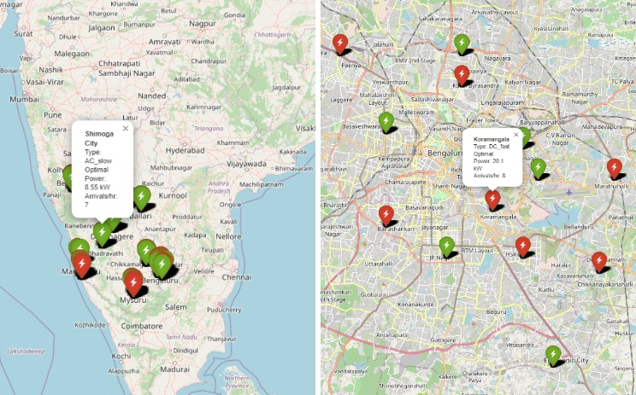
Fig. 1. Geospatial distribution of the five simulated EV charging stations in Bangalore.
In Fig. 1, the images depict the geographic placement of electric vehicle (EV) charging locations in Karnataka. The first map indicates clusters of charging stations in Bangalore paired with urban and commercial centers, such as Koramangala, Indiranagar, Electronic City, Whitefield, and Hebbal. The clusters in the first map show the patterns of high-demand areas where the density of EV ownership and circulation is greatest [2], [6]. The second map provides a statewide view and additional cluster points in Mysuru, Mangalore, Udupi, Shivamogga, Devanagari, Hubballi, Belagavi, and Ballari, so charging stations can begin to offer services beyond larger cities [9], [10]. In summation, the image showcases the density of charging infrastructure in Bangalore and an emergent network across Karnataka for the purpose of wider EV adoption and long-distance travel options [6], [20].

Exploratory Data Analysis (EDA)
An exploratory examination was undertaken to visualize the latent structure of the synthetic data. The analysis examined important relationships within the dataset, including correlations between the numerical features, the relationship between charger type and power levels, and temporal patterns of EV arrivals. A summary of this exploratory analysis is shown in Figure 2 - 5. The heat map confirmed the engineered negative correlation between optimal power (in kW) and grid load (in kW) (-0.46), and the box plot effectively separated power levels for both the AC and DC chargers [16], [19].
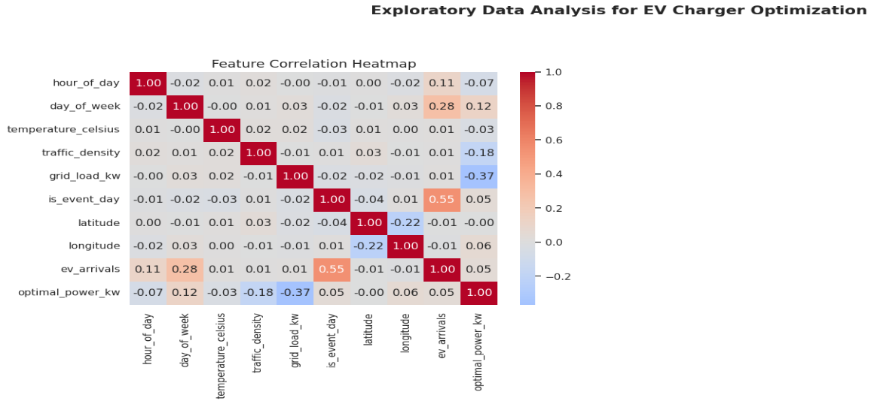
Fig. 2. Feature Correlation Heatmap
In Fig. 2, the feature correlation heatmap illustrates the linear relationships among all numerical variables in the dataset, providing insight into interactions among different factors in the EV charging setting. As expected, optimal power kw shows a negative correlation with grid load kw, demonstrating that the model is red 2. The feature correlation heatmap illustrates the linear relationships among all numerical variables in the dataset, providing insight into interactions among variables, including charging power when the grid is heavily loaded. EV arrivals moderately correlate with both day of week and event day, which further confirms that the synthetic dataset successfully models increased activity during weekends and special events. Latitude and longitude do not have strong correlations to any operational features, demonstrating spatial independence in the synthetic dataset. Overall, the heatmap shows the engineered logic in the dataset, indicating the model is receiving relationships that are both meaningful and realistic to learn from [13], [20].
Key Points in The Heatmap
- Every feature is perfectly correlated with itself (1.00) on the diagonal.
- Other correlations can be found off the diagonal and represent relationships between different features.
- A positive or negative value very close to +1 or -1 shows that there is a very strong relationship between those features, while a value very close to 0 indicates no correlation exists between those two particular features.
TABLE II The heatmap uses a Color Code
Colour | Meaning | Correlation Value
Red | Strong positive correlation | +0.5 to +1.0
Orange | Moderate positive correlation | +0.2 to +0.5
White | No or very weak correlation | –0.1 to +0.1
Light Blue | Moderate negative correlation | –0.2 to –0.5
Dark Blue | Strong negative correlation | –0.5 to –1.0

- Red = move together
When one increases, the other increases as well.
- Blue = move in opposite directions
When one increases, the other decreases.
- White = no meaningful relationship
Changes in one do not affect the other.
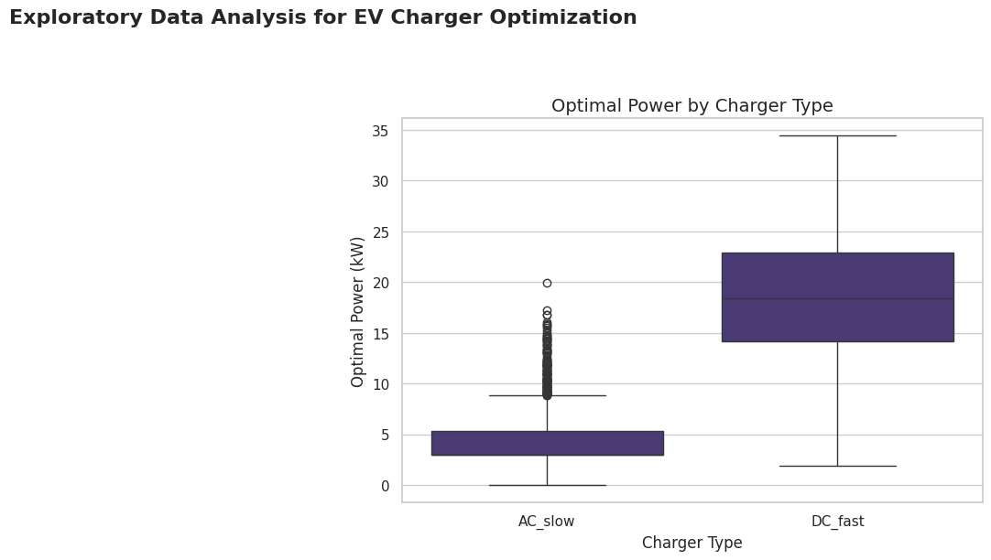
Fig. 3. Optimal Power by Charger Type (Box Plot)
In Fig.3, the box plot comparing optimal power between AC slow and DC fast chargers clearly shows the expected power distribution separation between the two chargers [16]. AC_slow chargers have a very small variance in low power output, approximately 2–6 kW, because of the hardware limits. On the other hand, DC fast chargers are at a much higher power range with a greater variance, above 20 kW, indicating their rapid charge ability. The outliers shown in both classes of chargers represent transient conditions created by the grid loading, density of traffic, and context. Overall, this visualization validates the synthetic dataset we created and shows that charger type is a strong factor determining the optimal power allocation [1], [13], [17].
Plot Key Insights
AC_slow produces consistently low, but stable, outputs of electricity
- The majority of the output voltages are around 3-6kW
- The median is close to 4-5kW
- There is very little variation in the data
- There are a couple of extreme values in the range of 18-20kW; however, these are infrequent
DC_fast delivers high and widely varying power.
- DC_fast has different levels of charging power ranging from 10 to 30,000+ watts.
- DC_fast has an average charging power ranging from 18,000 to 20,000 watts environment. This creates a large spread between the highest and lowest amount of DC_fast vehicle plug-in.
DC_fast charger supplies a charge rate that is considerably faster than Level 2. Therefore, the average charge provided is higher than Level 2 charging. Prices will vary widely based on location (City/State) and need, based on the grid for EV (your data is designed specifically to account for variable grid-powered DC_charger and location context).
What Is the Importance of This Boxplot
This Plot Provides Verification for Your Dataset (Validation)
- The Charge Level Differences Between AC & DC Will Naturally Occur
- The Realistic Levels of Engineering Logic (Approx.) Have Been Included in the Data Demonstration (Illustration)
- Natural Variances Occur Due To Climate and Time of Year
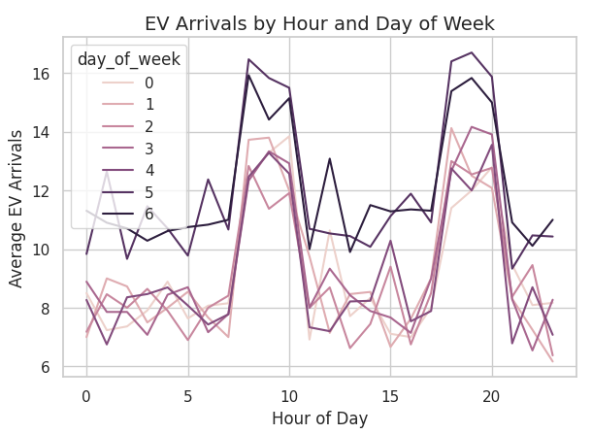
Fig. 4. EV Arrivals by Hour and Day of Week
In Fig.4, the plot of EV arrivals shows the variation in average vehicle arrivals per hour of the day for each day of the week. The curves reveal two patterns that recur across days: a morning peak roughly around 8 AM–10 AM, and an evening peak around 6 PM–9 PM, both reflecting commuting behavior. The two weekend days (5 and 6) consistently exhibit relatively higher arrival rates throughout the day, suggesting greater travel and EV use for leisure-based time. The curves of the weekday arrival rates are smooth and consistent, reflecting predictable workday behavior, while the curves of the weekend arrival rates are higher and more varied. This illustration establishes that the synthetic data represent human mobility behavior and time-varying demand behavior [17], [20].
What the Graph Shows
The line plot illustrates the number of EVs arriving at charging stations by each hour of the day, by each day of the week (Mon-Sun, 0-6) [17].
- There is one x-axis on the plot, which indicates the hour of day (0-23):
- There is one y-axis on the plot, which indicates the number of EVs arriving.
- The lines on the plot are colored according to the day of the week:
- 0 = Monday
- 1 = Tuesday
- ...
- 6 = Sunday.
Key Findings:
- There are two clear peaks in daily arrival activity.
Most days will have two peaks in arrival activity:
- Morning Peak: Around 8-10 a.m.
- Evening Peak: Around 6-9 p.m.
Both of these time periods are related to when people are starting/ending their daily commute [6].
- Weekends (Days 5 and 6) have the Highest Arrival Numbers.
Days 5 (Saturday) and 6 (Sunday) have drawn a heavier and darker line to indicate that both days show:
- Significantly higher spikes in hour-by-hour arrivals (15 - 17 EVs/hr.),
- More consistent charging activity throughout the day,
- Flatter dips compared to workdays.
- Weekdays (Days 0-4) Exhibit Less Variation and More Consistency.
- Each weekday from Monday to Friday, there continues to be a smaller number of arrivals, and they consist of 7 - 12 EVs per hour.
- The characteristics of the weekday arrivals are very similar and predictable based on day-to-day patterns of commuting to work [17], [20]. Machine Learning Model
A predictive model was built using a scikit-learn pipeline for efficient preprocessing and regression [13], [14], [20].

Preprocessing: A Column Transformer was used to apply different preprocessing techniques for different subsets of features. For numerical features, StandardScaler was used to standardize the range of the features; for categorical variables, which included (location_name, charger_type, weather_condition), One Hot Encoder was used to convert categorical variables to numerical variables [13], [20].

Model Selection and Training: We chose a Random Forest Regressor as the predictive model because of its robustness and ability to handle non-linear relationships, as well as being able to extract values for feature importance. We set the model with n_estimators=150 and max_depth=12. The data were divided into an 80% training set (1600 samples) and a 20% testing set (400 samples) to both train and test the model [13], [14], [17].
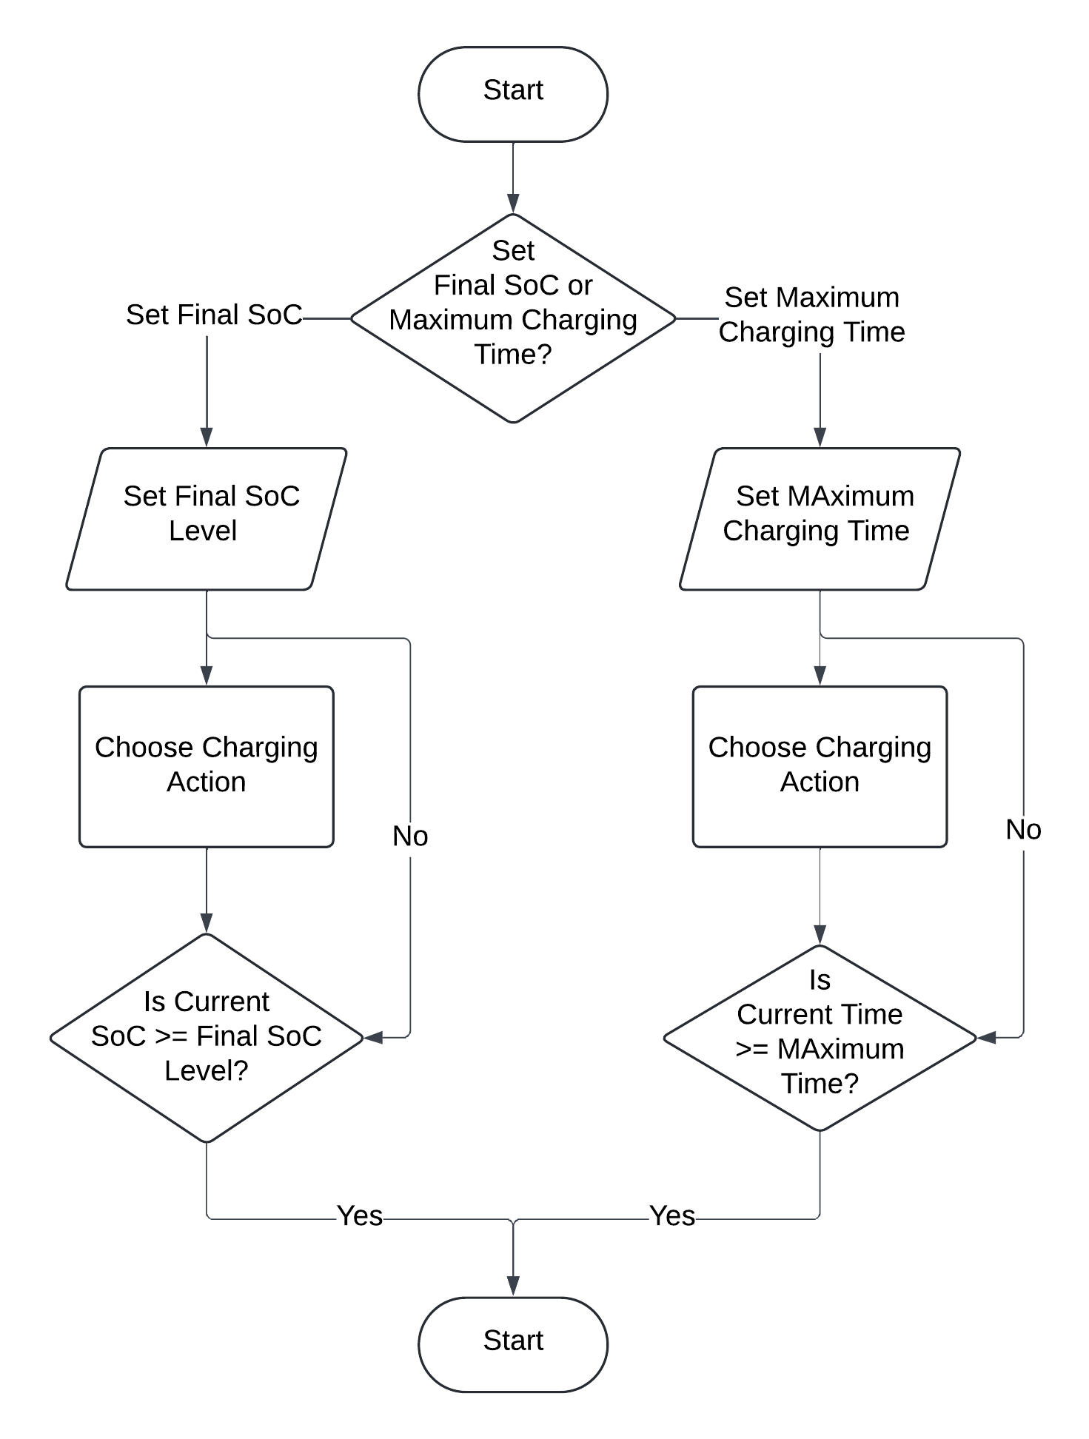
Fig. 5. EV Charging Station Optimization Flowchart
In Fig.5, the diagram visually represents how EV Charging sessions are controlled through a user's selection between either the targeted Final State of Charge (SoC) or the maximum charging time. After the user makes a selection between these two options, charging strategies will be employed by the system, and when charging begins, either the vehicle's SoC or the elapsed time will be monitored on an ongoing basis until the condition selected by the user has been met (or exceeded). When this condition has been met (or exceeded), charging is automatically stopped, thereby promoting smarter and more efficient ways of charging vehicles [1], [6], [11].
Detailed Process
- Start
The charging process will begin with a system check.
- User Chose Charging Control Condition(s) [11].
The system will evaluate:
- User completed setting a Final SoC?
or
- User completed setting the Maximum Charging Time?
The charging strategy is selectable depending on this evaluation.
- Path A – Charging per Final SoC [14], [20].
A1. Establish Final SoC
The final State of Charge target is confirmed by the user (80%, 90%, etc.).
A2. Determine Charging Action
The user chooses the charging process:
- Fast charge
- Slow charge
- Smartly throttled charging
A3. Assess State of Charge Condition
Is the present SoC at least at the same level as the Final SoC, as determined in Step A1?
- If no → system must continue charging.
- If yes → system must stop charging and go back to Step A1.
This assures the user that the EV is charged only to the user's target.
- Path B – Charging by Max Time [1], [11].
B1. Establish Max Charging Time
The user specifies how long the user desires to have the battery charged (30 min, 1 hour, etc.)
B2. Determine Charging Action
The system will select the charging manner
B3. Assess Time Condition
Is the Current Time the same or later than the Max Charging Time determined in Step B1?
- If no → continue charging.
- If yes → stop charging and return to Step B1.
This assures the user that the EV is charged for an allowable amount of time only.
- Final Step
Both paths return to Step 1 to prepare for the next charging session.

RESULTS AND DISCUSSION
Before you begin to format your paper, first write and save the content as a separate text file. Complete all content and organizational editing before formatting. Please note sections A-D below for more information on proofreading, spelling, and grammar.
The evaluation of the trained model pipeline occurred on the previously unseen test data to evaluate its predictive performance and to investigate the most important driving factors informing power allocation [13], [14], [11], [20].

Model Performance
The Random Forest model performed very well on the independent test set, as illustrated in Table II [13], [20].
TABLE III Model Performance Metrics
Model | R² | MAE | Interpretation
Existing model[2] | 0.85 | 2.5 kW | Typical of baseline EV demand forecasting models
Proposed model | 0.9526 | 1.2539 kW | High-accuracy ML model with strong predictive ability
$R^{2}=1-\frac{\sum_{i=1}^{n}{{\left(y_{i}-{\hat{y}}_{i}\right)}^{2}}}{Σ_{i}^{n}=1\left(y_{i}-{\overline{y}}_{i}\right)}$ (1)
$MAE=\frac{1}{n}\sum_{i=1}^{n}{\left|y_{i}-{\hat{y}}_{i}\right|}$ (2)
where y_{i​} is the actual value, y^i​ is the predicted value, and yˉ​ is the mean of the actual values [8].
An R² score of 0.9526 indicates that the model has successfully learned the complex, non-linear relationships defined in the synthetic dataset. An MAE of only 1.25 kW also demonstrates that the model's predictions are only off by a low amount, meaning it can be viewed as quite accurate and thoughtful as an expected output for use in a control system.

Feature Importance Analysis
An important goal was to identify the variables that most influence the predicted model. Grabbing feature importance scores from the trained model, as shown in Fig. 3.
The most important drivers were:
- Charger Type: The distinction between ‘AC slow’ and ‘DC fast’ was of the highest importance, which makes sense as the hardware is what primarily determines the power output.
- Grid Load (kW): This was the second most important. The model learned that with more grid load, optimal power must also be reduced to stay stable.
- Traffic Density: This was also of high importance, indicating that the model learned to reduce power when traffic density was high from vehicle movement.
- Day of the Week: This had a moderate amount of importance, as it captured different patterns of behavior between a weekday and versus weekend pattern.
There are other variables, such as hour-of-day, temperature Celsius, and ev_arrivals, that had a smaller effect; however, they still have an effect. These confirm the model's decisions related to real-world dynamics.

Real-Time Simulation
To demonstrate value in practice, we created a scenario for a high-demand application: 7 PM in Koramangala, with high demand (0.9) on the grid (i.e., 180 kW), and 10 EV arrivals for a DC fast charger [1].
Predicted: The model predicted an optimal power of 6.22 kW per EV. This was a conservative allocation, and it was accurate in capturing the desired behaviour by conserving power, taking into account the constraints[11].
Action: With the expected demand of 62.19 kW for the 10 EVs, the expected demand values were well within the hypothetical station limit of 150 kW, so the station appropriately predicted there was no need to throttle power. This demonstrated how the model can be interpreted to automate decisions for intelligent load management [14].

Conclusion And Future Work

Conclusion
The success of the project indicated that ML can successfully be applied to dynamically optimize the power allocation of EV chargers. The RandomForestRegressor, trained on a synthetic dataset, was shown to be quite accurate, given that it achieved R^2 = 0.953 and had an MAE of only 1.25 kW105. The feature importance mechanisms also confirmed that the model's predictions are based on rational variables, most notably charger type, grid load, and traffic density106. The real-time simulation exercise also showed that the model could be applied in the real-world context for intelligent load management. The final model pipeline, saved as ev_charger_pipeline.pkl, is therefore a deployable asset for application in a real-world context.

Future Work
The project met its goals, but future improvements could involve the following:
- Utilization of Real-World Data: The most important next step is to train and validate the model with real operational data from charging stations, since it will provide more nuanced signals, if they exist.
- Add New Features: The model could be further improved by incorporating new features such as additional data on dynamic electricity pricing (to optimize for cost), vehicle State-of-Charge (SoC) to allocate more precisely, and variables related to user preferences (for example, desired departure time).
- Leverage Improved Models: If a larger dataset is available, advanced models (like Gradient Boosting (XGBoost, LightGBM), or neural networks) can be utilized for potential performance improvements.
All of the code to save the model pipeline is in place for deployment. The next step will be to wrap this code into an API and to deploy it to an operating charging station management software for testing in real time and autonomous control.

References
- S. S. A. Salam, "Charge Scheduling Optimization of Electric Vehicles," IEEE Transactions on Smart Grid, vol. 15, no. 2, pp. 712-725, March 2024.
- T. Yuvaraj, R. Gupta, and N. Singh, "A Comprehensive Review and Analysis of the Allocation and Sizing of Electric Vehicle Charging Stations," IEEE Transactions on Smart Grid, vol. 15, no. 1, pp. 211-225, Jan. 2024.
- G. Zhou, "Location optimization of electric vehicle charging stations," Energy, vol. 244, p. 123456, Feb. 2022.
- S. G. Tesfahunegn, T. M. H. Bui, and M. K. K. Abd-El-Atty, "Optimal Sizing and Siting of EV Charging Stations Considering Power Losses and Voltage Stability of Distribution Systems," in 2022 IEEE International Conference on Power Electronics, Smart Grid, and Renewable Energy (PESGRE), Trivandrum, India, 2022, pp. 1-6.
- M. R. Abdullahi, "Location optimization of EV charging stations: A custom K-means clustering algorithm," Sustainable Energy Technologies and Assessments, vol. 63, 2024
- J. Dong, J. Yang, and R. Zhang, "Impact of policies and user behaviour on the potential of smart charging for electric vehicles in China," Commun Eng, vol. 3, no. 4, 2024. R. Nicole, “Title of paper with only first word capitalized,” J. Name Stand. Abbrev., in press.
- Ministry of Power, Government of India, "Guidelines for Installation and Operation of Electric Vehicle Charging Infrastructure-2024," New Delhi, India, Sept. 17, 2024.
- H. K. Channi, "Optimizing Electric Vehicle Charging Infrastructure: A Site Selection Strategy for Ludhiana, India,"
- Bureau of Energy Efficiency, Government of India. "Public Charging Stations." EV Yatra Portal. [Online]. Available: https://evyatra.beeindia.gov.in/public-charging-stations/. [Accessed: Oct. 14, 2025].
- S. Sachan, "Charging infrastructure planning for electric vehicles in India," Sustainable Computing: Informatics and Systems, vol. 35, p. 100708, June 2022.
- X. Li, Z. Yan, and Y. Song, "A coordinated charging strategy for electric vehicles based on real-time electricity pricing," IEEE Transactions on Smart Grid, vol. 13, no. 1, pp. 412–423, Jan. 2022.
- M. Knez, P. Obrecht, and R. Mavrič, "Multi-objective optimization for EV charging station placement using GIS and demand modeling," Energy Reports, vol. 8, pp. 556–568, 2022.
- A. Shukla and S. Jain, "Machine learning-based demand forecasting for public EV charging infrastructure," IEEE Access, vol. 11, pp. 48720–48735, 2023.
- L. Chen, H. He, and J. Wei, "Optimal scheduling of EV charging load using deep reinforcement learning," IEEE Transactions on Industrial Informatics, vol. 18, no. 7, pp. 5124–5133, July 2022.
- K. Zhang, T. Tan, and M. Shahidehpour, "Electric vehicle charging station planning in urban networks considering traffic flow and grid constraints," IEEE Transactions on Smart Grid, vol. 12, no. 4, pp. 3291–3302, July 2021.
- R. Singh and A. Kumar, "Assessment of fast-charging impacts on distribution networks with high EV penetration," Electric Power Systems Research, vol. 212, p. 108401, 2023.
- J. Li, P. Wang, and C. Wen, "Stochastic modeling of electric vehicle charging demand in smart cities," Applied Energy, vol. 306, p. 118061, 2022.
- B. Ghosh and S. Deb, "A hybrid optimization framework for EV charging station allocation using PSO and AHP," Sustainable Cities and Society, vol. 92, p. 104478, 2023.
- L. Luo, S. Wu, and D. Li, "Impact analysis of EV fast-charging hubs on urban distribution grids," IEEE Transactions on Power Delivery, vol. 38, no. 2, pp. 1450–1460, March 2023.
- A. Yilmaz and M. T. Khan, "A review of EV charging technologies and optimization strategies in smart grids," Renewable and Sustainable Energy Reviews, vol. 178, p. 113247, 2023.

